TrashedWorld
Module 1 - Unit 3 - Investigation sheet of Miglena Bogdanova
(use the useful language given if you need to)
- This is a photo of the grocery shop in the film you saw. Take a picture inside a local shop and place it with this photo. Write a comparison of the two pictures to present back in class. Look carefully at packaging! Take photos of some of the packaging and the recycling information.

Picture 1
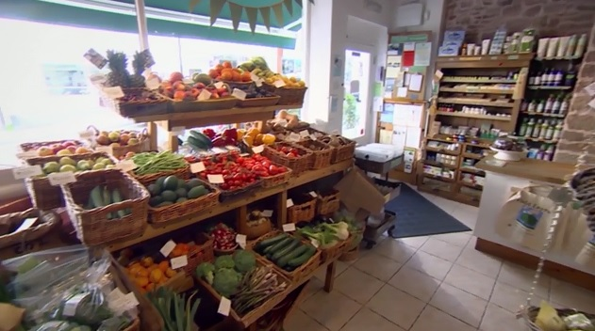
Picture 2
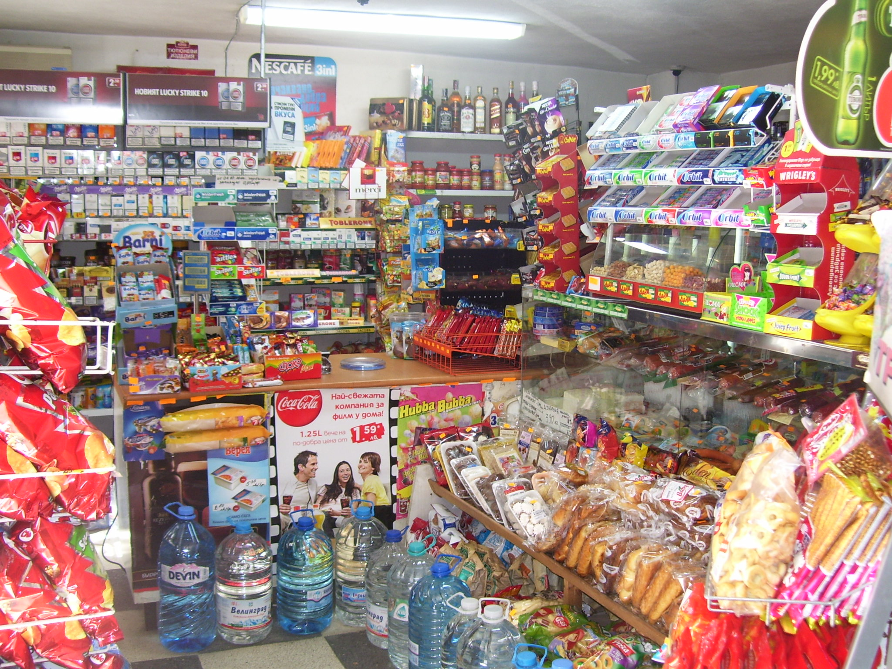

Useful language:
Some similarities are...
I think the main differences are...
In picture one there is more-less / are more-less...
The first shop has more-less...
. What happens with your waste at home? How many waste bins do you have? Where are they located?
We have two bins–one big in the yard and one small in the kitchen.

- Do you separate your waste? How is it separated?
Waste (glass/paper/plastic/metal) is not separated. We don’t have separate bins for each material because we know that even if we separate it all the rubbish will be put back together and thrown in the rubbish dump.

- How much waste do you create at home over one week?

Waste | kilos | litres
Paper, card | 0.3
Glass | 0.0
Metal | 0.0
Plastics | 0.4

(Remember! bring this information back to class to share.)

- Are there any other types of waste (food, batteries, oil etc)?

- How much of your week's waste goes to a landfill (incinerator, dump), how much goes to recycling?
100% goes to a dump and
0 % goes to recycling

- Gather together all the information from your class. Create a local shop gallery with images of the recycling symbols you found. Present the data and the gallery in an interactive visual form to send to your partner/s. Your teacher will give you ideas, but do be creative and use your own!

